

Documentation

07.12.2021

ERROR 404



Physics calculator and two more games on C++ console

Contents

Physics Calculator and 2 more games…………………………………………………………………………………..............3

Project Information and plan……………………………………………………………………………………............3

Team Information…………………………………………………………………………………………………….............3

Introduction………………………………………………………………………………………………………………………..3

Ways of Realization………………………………………………………………………………………………................4

Testing the plan………………………………………………………………………………………………………………..................5

Tasks for completion………………………………………………………………………………………………..............5

Calculator operations…………………………………………………………………………………..……………………...6

Controls and game rules: Catch the leaf……………………………………………………………………………….6

Controls and games rules: Doodle Jump………………………………………………………………………………7

Test plan……………………………………………………………………………………………………………………………………..…...8

Code plan…………………………………………………………………………………………………………………………….8

Block scheme...................................................................................................................................... .10

Functions descriptions........................................................................................................................ 10

PHYSICS CALCULATOR AND 2 MORE GAMES

**Project Information**

Our project is made for easy use and entertainment. We created a calculator and 2 games.

**Team Information**

|  |  |
| --- | --- |
| **№** | **Roles in the team** |
| **1** | Stefan Hristov – Scrum Trainer |
| **2** | Hristiyan Petrov – Quality Assurance |
| **3** | Maksim Marinov – Back End Developer |
| **4** | Mihail Petrov – Back End Developer |

**Introduction**

|  |  |
| --- | --- |
| **№** | **Introduction** |
| **1** | What is the product?  The product consists of a physics calculator and 2 games. The calculator utilises physics formulas thus making it easy for the customer to acquire needed information simply and conveniently. The games are made for entertainment of the customer. |
| **2** | How can you access it?  You can read about our collaborative work on GitHub and access the files in our project’s repository. |
| **3** | What about communication?  We communicated through Teams due to its helpful functions like screen sharing and text channels. The team was well connected and the work was efficient. |
| **4** | What programs were used?  Programs we used consisted of GitHub for file management and collaborative work, Visual Studio for code editing, MS Teams for communication, MS PowerPoint for our Presentation and MS Word for the documentation. |

**Ways of Realization**

|  |  |
| --- | --- |
| **№** | **How did we do it?** |
| **1** | Task Distribution  The Tasks were distributed based on the skillset of everyone. We also notified each other when changes were made to project so everyone was always up to date. This way our team was as productive as possible. |
| **2** | Task Completion  Every day at around 20 p.m. we held a meeting to track the development of the project and help each other progress further. It also helped us resolve issues and share ideas. |
| **3** | Deadlines  In these meeting we also discussed time management, how specific parts were coming along, what everyone had done in their specified time and what things should be completed in the near future. |

TESTING THE PLAN

**Tasks for Completion**

|  |  |
| --- | --- |
| **№** | **Task Breakdown** |
| **1** | Creating the Main menu  The main menu was created by the back-end / front-end developers so you can navigate the entire application with it. |
| **2** | Creating the calculator’s menu  The calculator’s menu was created by the back-end / front-end developers and through it you can access every single calculator. |
| **3** | Creating the calculator’s design  The calculators were created by the front-end developers with the purpose of being user-friendly and easy to read / use. |
| **4** | Creating the calculator’s functions  The functions of the calculators were created according to the used physics formulas by the back-end developers. |
| **5** | Creating “Catch the Leaf” window and textures  To create the window and textures our back-end developers chose to use SFML (simple and fast media library). |
| **6** | Creating “Catch the Leaf” movement and collision  To create the movement and collision our back-end developers used the screen coordinates in the window created by SFML. |
| **7** | Creating “Doodle Jump” window and textures  To create the window and textures our back-end developers chose to use SFML (simple and fast media library). |
| **8** | Creating “Doodle Jump” movement and collision  To create the movement and collision our back-end developers used the screen coordinates in the window created by SFML. |
| **9** | Documentation  The documentation was created by the QA engineer and our scrum-trainer using to summarise the application and explain its functions. |
| **10** | Presentation  The presentation was created by the QA engineer and our scrum-trainer to explain the concept of the application, specify the used programs and establish the roles of the teams. |

**Calculator operations**

|  |  |
| --- | --- |
| **№** | **Input and Output** |
| **1** | Input  When you have chosen the calculators function, click over to the valuable you need then input the other parts of the formula and click Enter. |
| **2** | Output  The calculator will output the chosen valuable with pression to the second number after the comma. |
| **3** | Controls  W – Move the pointer one block up  A – Moves the pointer one block to the right  D – Moves the pointer one block to the left.  S – Moves the pointer one block down.  Enter – Select Option |

**Controls and game rules: Catch the Leaf**

|  |  |
| --- | --- |
| **№** | **Controls and game rules** |
| **1** | Controls  Use the left click of the mouse to keep the leaf away from the borders. As long as you are holding down the left button of the mouse the leaf will move with the mouse pointer. |
| **2** | Objective  Don’t let the leaf, flying in the wind, touch the borders of the window and keep your score above 0. |
| **3** | Points  You start with 100 points and every time the leaf touches the border(s) of the window 5 point are deducted |
| **4** | Useful strategy  It’s easier to catch the leaf while keeping the left mouse button down. |

**Controls and games rules: Doodle Jump**

|  |  |
| --- | --- |
| **№** | **Controls and game rules** |
| **1** | Controls  A or right arrow – Moves the character to the right  D or left arrow – Moves the character to the left |
| **2** | Objective  Get the character as high as you can while keeping it on the floating platforms. |
| **3** | Points  The points start at 0 and for every jump going upwards you get more. |

TEST PLAN

**Code Plan**

|  |  |  |  |  |
| --- | --- | --- | --- | --- |
| **№** | **Action** | **Deadline** | **Completion %** | **Completed by** |
| **1** | Home Screen | 22.11.2021 | 100% | Front End |
| **2** | Main Menu | 05.12.2021 | 100% | Front End  Back end |
| **3** | Main Menu Options | 05.12.2021 | 100% | Front End  Back end |
| **4** | Calculators Menu | 03.12.2021 | 100% | Front End  Back end |
| **5** | Calculators Menu Redirections | 02.12.2021 | 100% | Front End  Back end |
| **6** | Increasing Acceleration Calculator Design | 30.11.2021 | 100% | Front End  Back end |
| **7** | Increasing Acceleration Calculator Functionality | 27.11.2021 | 100% | Scrum Trainer Back End |
| **8** | Decreasing Acceleration Calculator Design | 30.11.2021 | 100% | Front End  Back end |
| **9** | Decreasing Acceleration  Calculator Functionality | 30.11.2021 | 100% | Scrum Trainer  Back End |
| **10** | Free Fall Calculator Design | 30.11.2021 | 100% | Front End  Back end |
| **11** | Free Fall Calculator Functionality | 30.11.2021 | 100% | Back End |
| **12** | Work and Power Calculator Design | 30.11.2021 | 100% | Front End  Back end |
| **13** | Work and Power Calculator Functionality | 30.11.2021 | 100% | Back End |
| **14** | Formulas Design | 05.12.2021 | 100% | Scrum Trainer |
| **15** | Formulas Functionality | 05.12.2021 | 100% | Scrum Trainer |

|  |  |  |  |  |
| --- | --- | --- | --- | --- |
| **16** | Hydrostatic Pressure Calculator Design | 30.11.2021 | 100% | Front End  Back end |
| **17** | Hydrostatic Pressure Calculator Functionality | 30.11.2021 | 100% | Back end |
| **18** | Pressure Calculator Design | 30.11.2021 | 100% | Front End  Back end |
| **19** | Pressure Calculator Design | 30.11.2021 | 100% | Scrum Trainer Back End |
| **21** | Arhimed’s Law Calculator Design | 30.11.2021 | 100% | Front End  Back end |
| **22** | Arhimed’s Law Calculator Functionality | 30.11.2021 | 100% | Scrum Trainer Back End |
| **23** | Unit Convertor Design | 30.11.2021 | 100% | Scrum-Trainer  Front End |
| **24** | Unit Convertor Functionality | 30.11.2021 | 100% | Scrum Trainer Back End |
| **25** | User Input Checker | 03.12.2021 | 100% | Back End |
| **26** | Doodle Jump Textures | 05.12.2021 | 100% | Back End |
| **27** | Doodle Jump Movement | 05.12.2021 | 100% | Back End |
| **28** | Doodle Jump Collision | 05.12.2021 | 100% | Back End |
| **29** | Doodle Jump Scoring System | 05.12.2021 | 100% | Back End |
| **30** | Catch The Leaf Textures | 05.12.2021 | 100% | Back End |
| **31** | Catch The Leaf Movement | 05.12.2021 | 100% | Back End |
| **32** | Catch The Leaf Collision | 05.12.2021 | 100% | Back End |
| **33** | Catch The Leaf Scoring System | 05.12.2021 | 100% | Back End |
| **34** | Code Checking | 05.12.2021 | 100% | QA Engineer |
| **35** | Documentation | 05.12.2021 | 100% | QA Engineer Scrum Trainer |
| **36** | Presentation | 05.12.2021 | 100% | QA Engineer Scrum Trainer |
| **37** | Doxygen | 05.12.2021 | 100% | Scrum Trainer |
| **38** | Readme | 06.12.2021 | 100% | QA Engineer Front End |

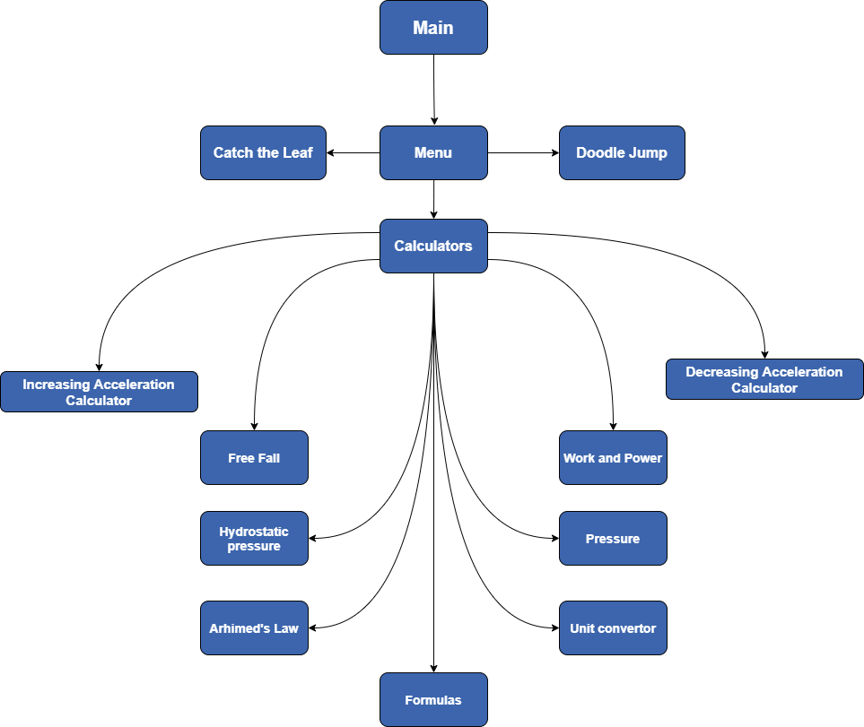BLOCK SCHEME

[FUNCTIONS DESCRIPTIONS](https://shhristov20.github.io/Physics-Project-2021/doxygen/_arhimeds_law_8cpp.html) (Ctrl + left click)